Title or Task: | Photoshop
Description: | Using the selection tools select various elements from the following files

Files Required
Suitable for Classes: | Multimedia, Small Business, Applied Information Technology Certificate II
Area: | Technology & Enterprise (ICT)
Teacher: | Mr Peter Faulks
Timeline | 2 lessons (this lesson requires 2 sessions)
Date Due: | In class
Task Brief: | This session requires some skill in using the mouse and various selection tools, it is used to take students through some basic aspects of Photoshop. It was based on Photoshop CS3 so some variations will occur if using other versions. It is rated easy and should give students confidence in starting Photoshop

Development or Outcomes:

Items highlighted in yellow are tasks for you to complete


Items in Blue italics are help tips

These pages are designed to show you how to use software packages; various software updates may have taken place so some pages will not apply to versions other than those listed here. In some cases data files may be required.

Copy these images to your folder or download the Photoshop_Images.zip

At the end of this document are some help pages that revise some of the tool functions

Simple logo design ideas using custom shapes in Photoshop

Learn how to create logo designs using shapes, styles, gradients in Photoshop.
Logos are very important parts of web designing and they can be made with letters and graphics. Here we will learn to design simple logos using custom shapes in Photoshop.
Click here for ready-made Photoshop logo designs
Smart, Colourful and unique Bird Logo
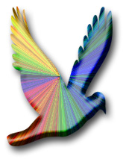
Let's start designing the logo. It's very simple.
Step 1: Open a new file by clicking on File>New choose International and A6 as shown
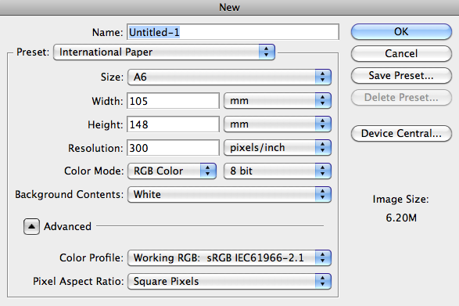
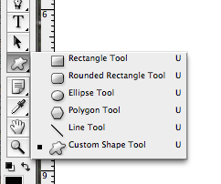
Step 2: Create a new layer. Name it logo.
Step 3: Choose the custom shape tool seen in the tools panel on the right.
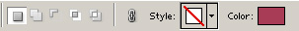
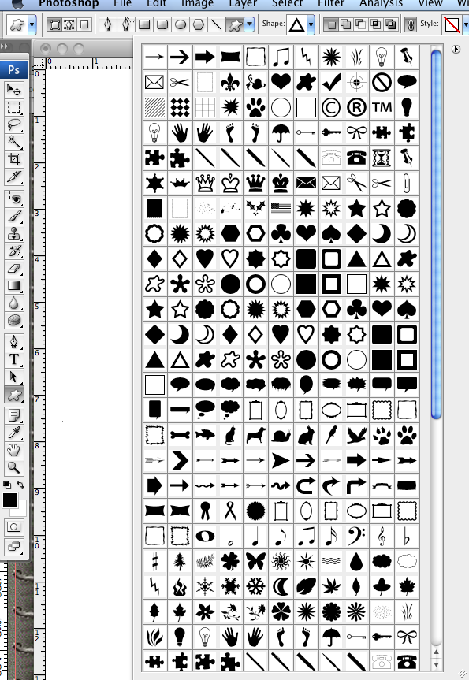
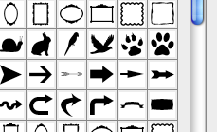
The above panel will appear.
Select Styles and as follows…
Step 4: Click on the Shape drop down menu seen on the top toolbar. Click on the arrow and select Animals. Select style as Buttons. Look for the angled spectrum button which is there. Look for the bird which is in the banner and drag it to the canvas with the size you want.
You may need to append the buttons to the styles
Use the little arrow on the style drop down and select Buttons then click Append (these will be at the bottom)
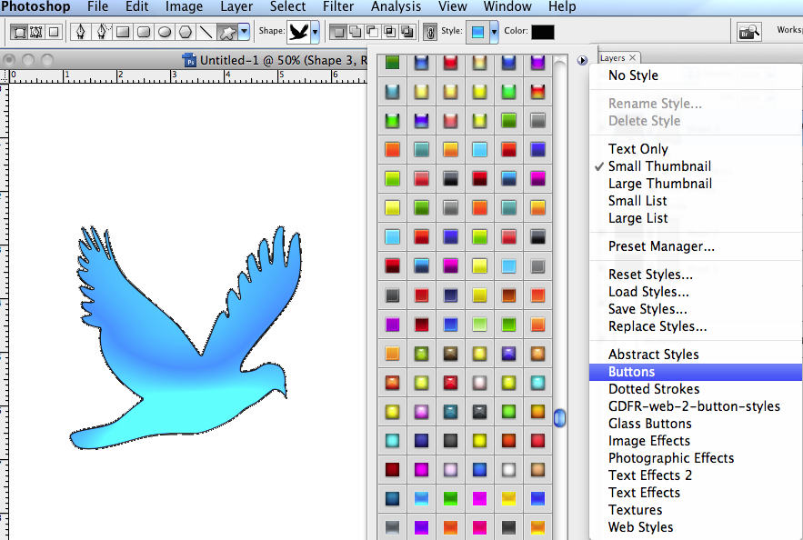
Now find the button angled spectrum button
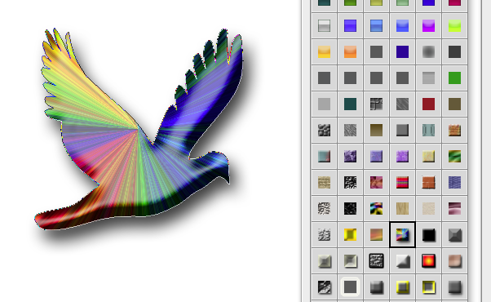

Wow! Your nice colourful Bird logo is ready!
Bright Sun Logo

Follow the steps:
Step 1:Choose the custom shape tool seen in the tools panel on the right. Click on the Shape drop down menu seen on the top toolbar.
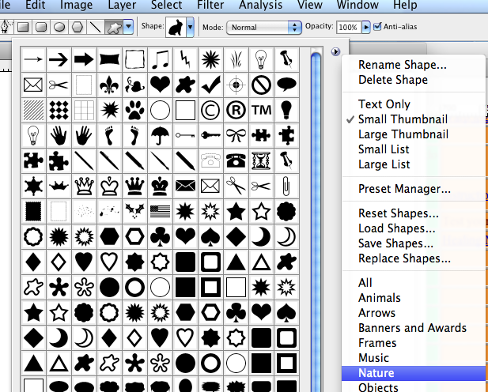
Click on the arrow and select Nature.
Look for the sun symbol which is there and drag it to the canvas with the size you want or draw it on your canvas.
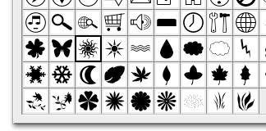

Make sure the mode is set to RPG
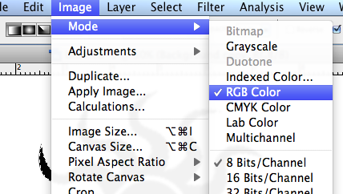
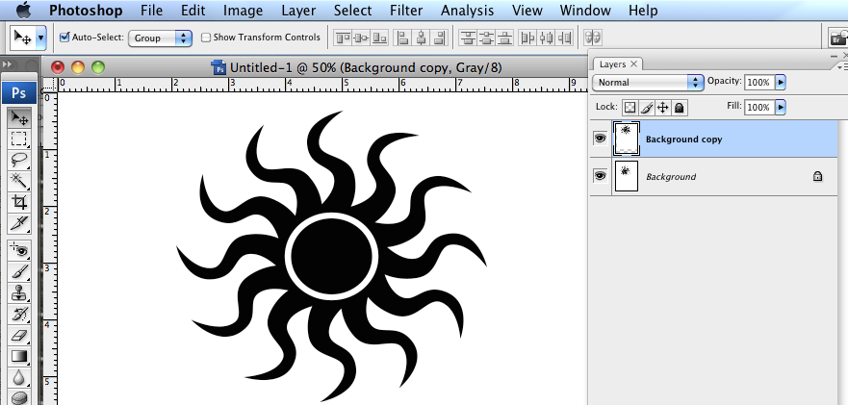
Select two colours in the Foreground and background palette I chose red (fb3204 ) and light yellow (eee2b3)
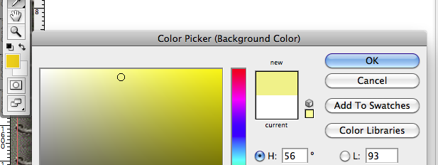

Step 2:Now click on magic wand tool and ste this to 32 then select the sun arms. Now create a gradient. Select Gradient tool . Select or use your colours or Color harmonies2 from the dropdown menu of gradient tool and chose the gradient which has orange to yellow gradient. Now click on the sun and drag from top to down. Your sun have the sun effect now.
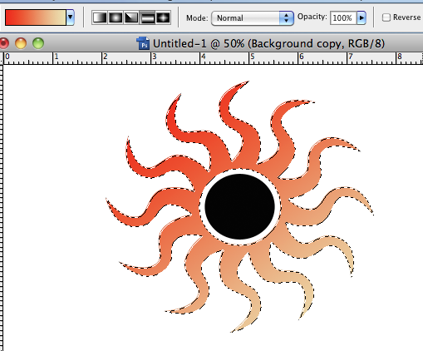

Play with the Gradient types and make your sun
Change the center gradient to radial Center and drag from the center
Paste three samples below:

Select Fill pixels 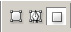(third button seen in the tools panel in the left).
Step 3:To make the text appear on top of the sun.
Click on and the below panel will appear on top of the photoshop file.
Select T and the below screen will appear.
Warp Text Screen Click on style as Arc Say ok.
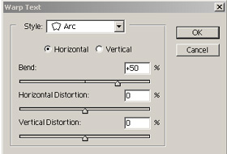
Now you can write your company name.

Your logo is ready!
Here is the logo we designed for the Free Photoshop website template 2.

Follow the steps:
Choose the custom shape tool seen in the tools panel on the right. Click on the Shape drop down menu seen on the top toolbar. Click on the arrow and select Ornaments. Look for the ornament which is in the banner of website header 2. Here give color as Black. Drag the shape to the canvas.

Easy isn't it? Click here to learn how we designed website template 2.
Here is the logo we designed for the Free Photoshop website template 3.

Follow the steps:
custom shape tool seen in the tools panel on the right. Go to Shape toolClick on this Shape drop down menu. Click on the arrow and select Symbols. Look for the star symbol which is in the banner of website header 2. Click on the color as #A83C56.
Drag the star in the canvas.

Your logo is ready!!! Click here to learn how we designed website template 3 .
Smart Star Logo
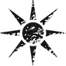
Follow the steps:
Choose the custom shape tool seen in the tools panel on the right. Click on the Shape drop down menu seen on the top toolbar. Click on the arrow and select Nature. Select style as Texture. Look for the pixelated texture which is there. Look for the star which is in the banner and drag it to the canvas with the size you want.

Your logo is ready!
Attractive Fire Logo

Follow the steps:
Step 1:First choose the custom shape tool seen in the tools panel on the right. Click on the Shape drop down menu seen on the top toolbar. Click on the arrow and select Symbols. Look for the first symbol which is in the banner.Select Fill pixels (third button seen in the tools panel in the left). Drag the fire symbol to the canvas.
Step 2:Now click on magic wand tool and select only the flames.
Step 3: Now create a gradient. Select Gradient tool. Select Color harmonies2 from the dropdown menu of gradient tool and chose the gradient which has orange to yellow gradient. Now click on the flames and drag from top to down. Your flames have the color effect of fire.
Step 4:Now choose the wood with magic wand tool and select the wood. Now choose a wood color like brown and fill it while choosing paint tool. Now go to filter/pixelate/fragment to get the wood effect.
Your fire logo is ready!
Congratulations! Your logo design is ready!

This Ends this Session

Help & Revision material

Brush sizes
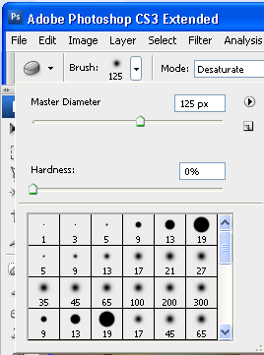
Note: It is useful to increase or decrease the brush size; select a brush type, soft edge hard edge or and effects brush... then use this slider
to change the size.
Drag the mouse over the image to check the size of the brush.

The Layers Palette

The Layers palette is your essential tool for working with layers. It contains a list of all your layers (referred to by name), starting with the topmost layer, and provides a thumbnail of the contents of each layer. Only one layer can be active at a time; the active layer is selected. You can use the Layers palette to perform many tasks (e.g., create, delete, hide, merge, and flatten layers).

To open the Layers palette:
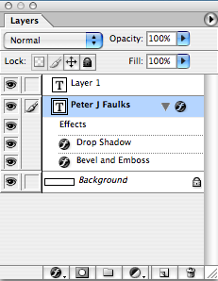

1. From the Window menu, Layers (F7)
The Layers palette appears on the Photoshop window.

To close the Layers palette:

From the Window menu, select Hide Layers
OR
Click the X in the upper right hand corner of the Layers palette
The Layers palette disappears from the Photoshop window into the dock – if you want you can drag the dock out onto the screen.

Note: The layer at the top of the list is the layer in front of all the other layers you can move (drag) layers up and down to get images in the correct stacking order.
Note you cannot move the background layer.

Add new layer style
Layer mask
Create a new set,
Create a new fill or adjustment layer
New layer
Trash delete layer

Hiding/Displaying Layers
You may find it useful to hide layers while working in Photoshop. For example, when merging layers, you can hide some layers so that they will not be merged. Visible layers have an EYE icon next to them, hidden layers do not appear when you save your work.

You can toggle between visible and hidden by clicking in the corresponding layer's Eye column.

Eyes shows or hides layer,
layer above is on top move up or down or add a new layer.

Help Note: Layer Selection Tips
When you select (i.e., click) a layer in the Layers palette, that layer is active. Review the following tips to learn about selection rules:

Only one layer can be active at a time, (highlighted in blue).

The name of the active layer appears in the title bar of the image window.

Changes affect only the active layer even though you view the whole image in the image window.

To hide several layers:
On the Layers palette, click the EYE icon corresponding to the layer(s) (and background) you wish to hide to select several layers click and drag within the Eye column to select the layers at once
These layers are now hidden.
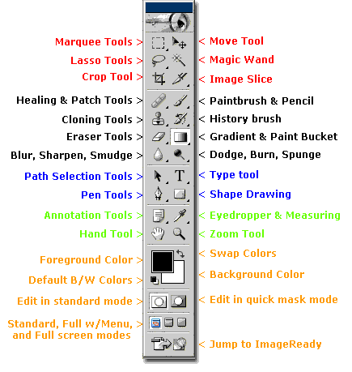

Photoshop Toolbox Reference
This section of the site is a comprehensive Photoshop Toolbox reference. Click on a tool to view its video-manual*.
Icon | Tool | Key | Purpose |  | Icon | Tool | Key | Purpose
 | Elliptical Marquee | M | selecting |  |  | Single Row Marquee | - | selecting
 | Rectangular Marquee | M | selecting |  |  | Single Column Marquee | - | selecting
 | Lasso | L | selecting |  |  | Move | V | transforming
 | Polygonal Lasso | L | selecting |  |  | Magic Wand | W | selecting
 | Magnetic Lasso | L | selecting |  |  | Crop | C | transforming
 | Slice | K | web design |  |  | Slice Select | K | web design
 | Healing Brush | J | retouching |  |  | Patch | J | retouching
 | Brush | B | painting |  |  | Pencil | B | painting
 | Clone Stamp | S | painting |  |  | Pattern Stamp | S | painting
 | History Brush | Y | restores to selected history state |  |  | Art History Brush | Y | painting
 | Airbrush | J | painting |  |  | Eraser | E | erasing
 | Background Eraser | E | erasing |  |  | Magic Eraser | E | erasing
 | Paint Bucket | G | painting |  |  | Gradient | G | painting
 | Blur | R | unfocusing |  |  | Sharpen | R | focusing
 | Smudge | R | painting |  |  | Sponge | O | color adjustment
 | Dodge | O | tonal adjustment |  |  | Burn | O | tonal adjustment
 | Horizontal Type | T | typing |  |  | Vertical Type | T | typing
 | Horizontal Type Mask | T | typing |  |  | Vertical Type Mask | T | typing
 | Direct Selection | A | drawing |  |  | Path Selection | A | drawing
 | Pen | P | drawing |  |  | Freeform Pen | P | drawing
 | Add Anchor Point | - | drawing |  |  | Delete Anchor Point | - | drawing
 | Convert Point | - | drawing |  |  | Rectangle | U | drawing
 | Rounded Rectangle | U | drawing |  |  | Ellipse | U | drawing
 | Polygon | U | drawing |  |  | LIne | U | drawing
 | Custom Shape | U | drawing |  |  | Eyedropper | I | choosing color
 | Color Sampler | I | color information |  |  | Measure | I | geometrical measurements
 | Notes | N | non-printable data |  |  | Audio Annotation | N | non-printable data
 | Hand | H | navigating |  |  | Zoom | Z | image viewing
 | Color Selecting box | - | displays current color |  |  | Color Replacement | J | retouching
 | Mode Selector | Q | selecting |  |  | Jump to Image Ready | Shift+  Ctrl+  M | web design

